Kafka Integration with C#:

1.Create a Chat Application which uses Kafka as a streaming platform and consume the chat messages in the command prompt.
KafkaProducerApp/program.cs:
using Confluent.Kafka;

class Program
{
static async Task Main()
{
var config = new ProducerConfig { BootstrapServers = "localhost:9092" };

using var producer = new ProducerBuilder<Null, string>(config).Build();

Console.WriteLine("Kafka Producer started. Type messages (type 'exit' to quit):");

while (true)
{
var message = Console.ReadLine();
if (message?.ToLower() == "exit") break;

await producer.ProduceAsync("chat-room", new Message<Null, string> { Value = message });
Console.WriteLine($"Sent: {message}");
}
}
}

KafkaConsumerApp/program.cs:
using Confluent.Kafka;

class Program
{
static void Main()
{
var config = new ConsumerConfig
{
BootstrapServers = "localhost:9092",
GroupId = "chat-group",
AutoOffsetReset = AutoOffsetReset.Earliest
};

using var consumer = new ConsumerBuilder<Ignore, string>(config).Build();
consumer.Subscribe("chat-room");

Console.WriteLine("Kafka Consumer started. Listening for messages...");
while (true)
{
var cr = consumer.Consume();
Console.WriteLine($"Received: {cr.Message.Value}");
}
}
}

OUTPUT:
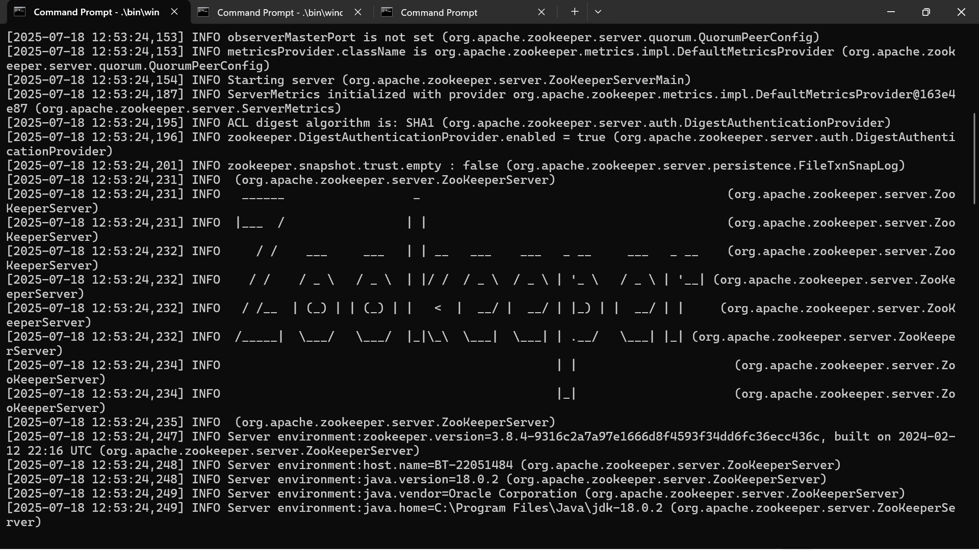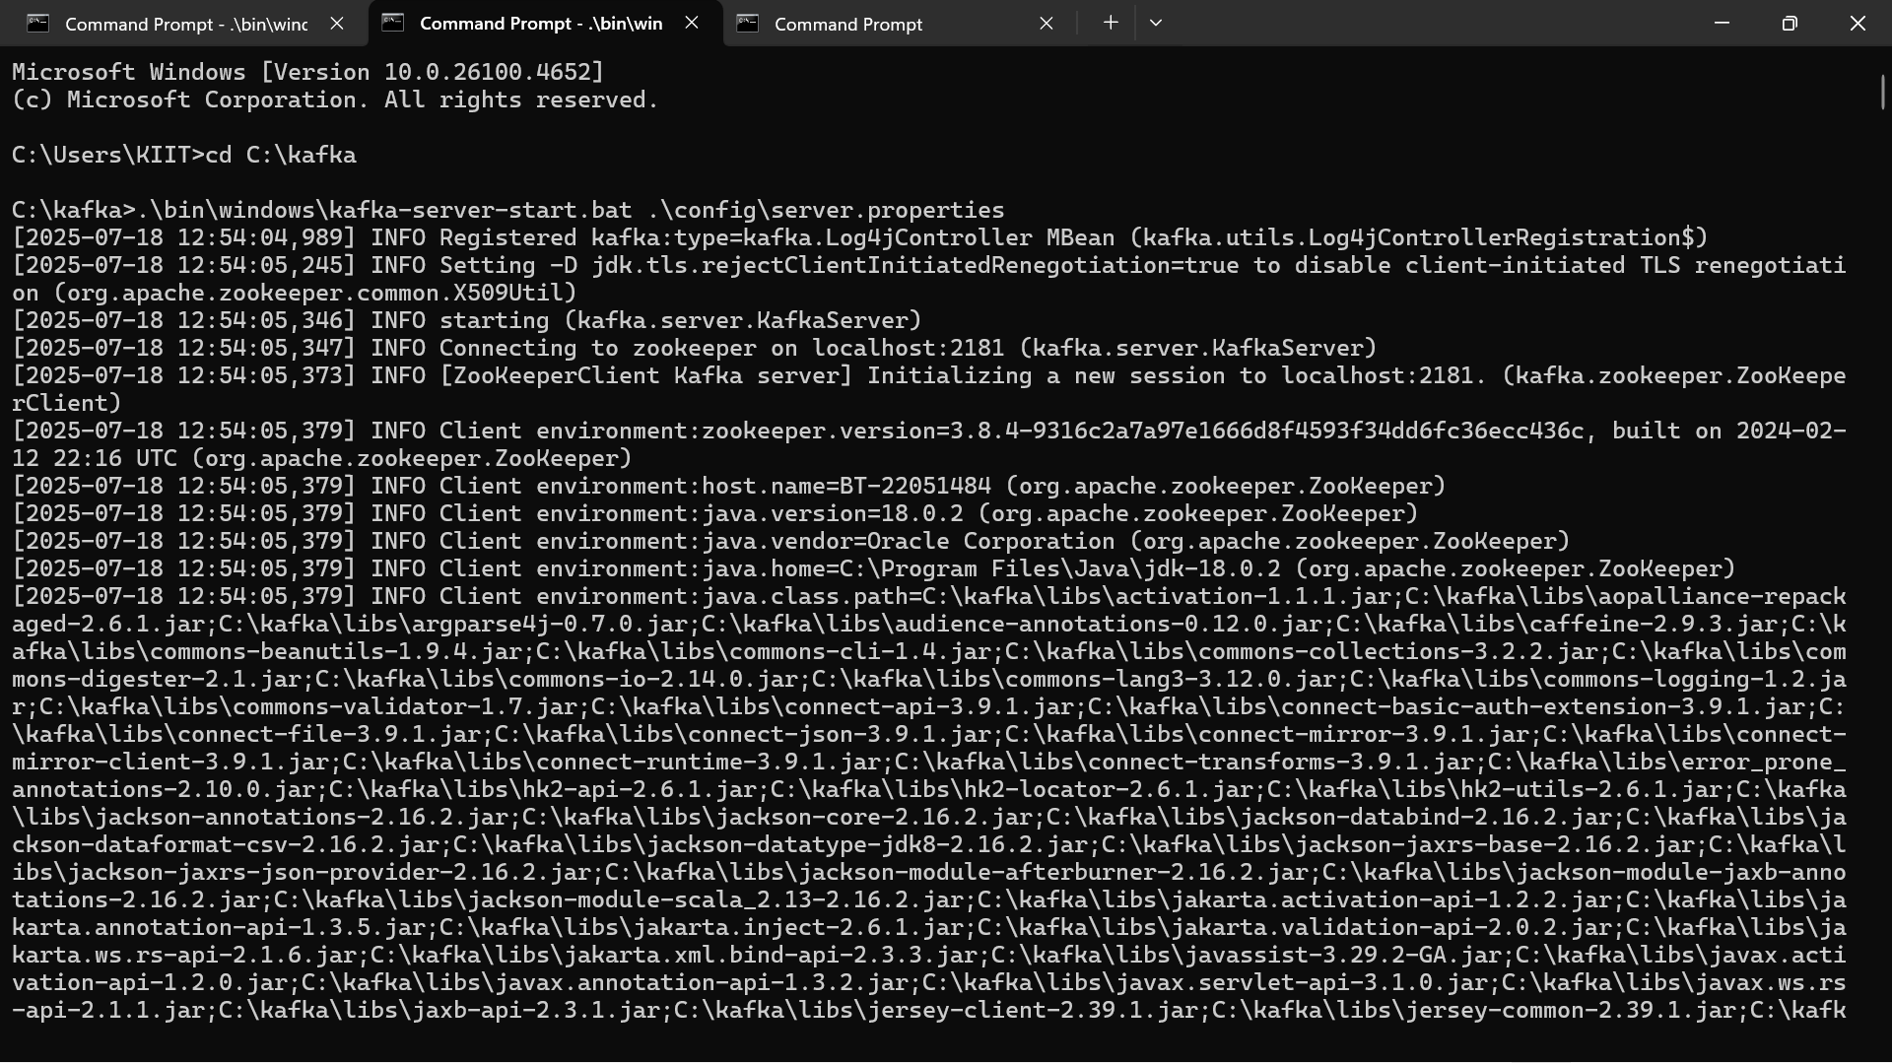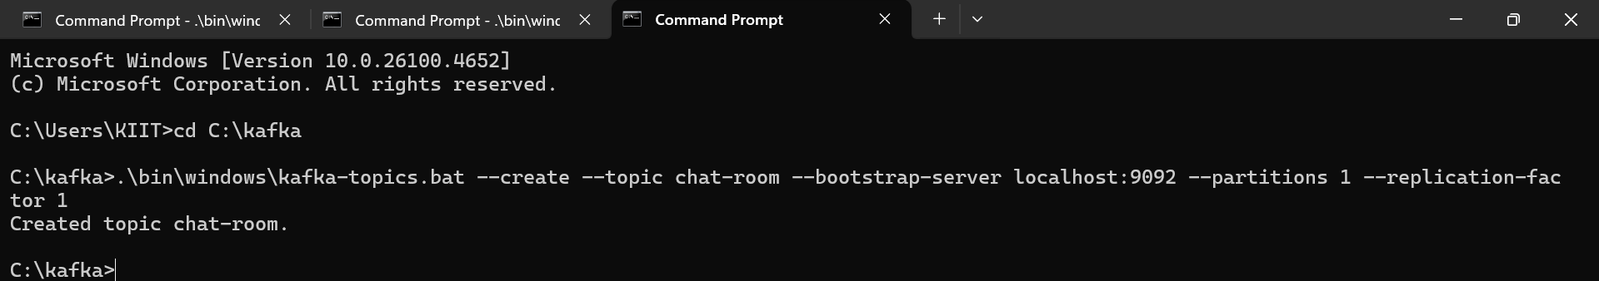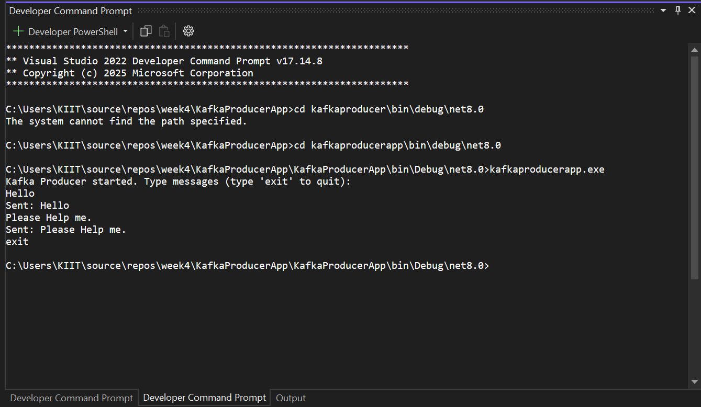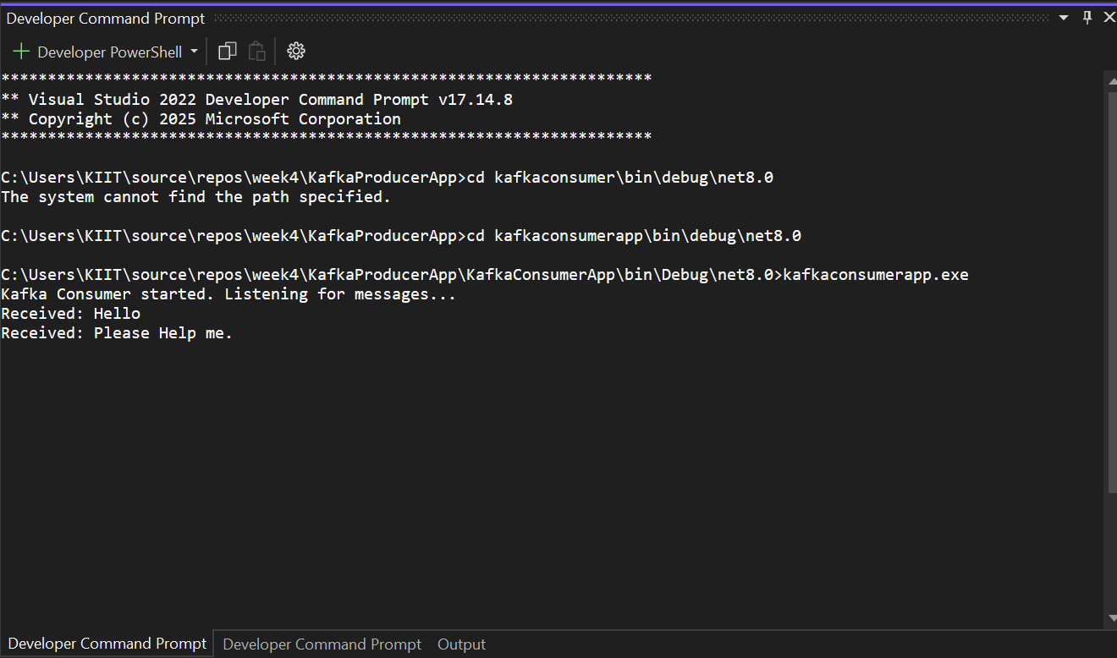

2.Create a Chat Application using C# Windows Application using Kafka and consume the message in different client applications.

Form1.cs:
using Confluent.Kafka;
using System;
using System.Threading.Tasks;
using System.Windows.Forms;

namespace KafkaChatWinApp
{
public partial class Form1 : Form
{
private IProducer<Null, string>? producer;
private IConsumer<Null, string>? consumer;
private readonly string topic = "chat-topic";
private readonly string clientId = "User-" + Guid.NewGuid().ToString().Substring(0, 4);
private bool isRunning = true;

public Form1()
{
InitializeComponent();
this.Text = $"Kafka Chat - {clientId}";
InitializeKafka();
}

private void InitializeKafka()
{
try
{
var producerConfig = new ProducerConfig
{
BootstrapServers = "localhost:9092"
};
producer = new ProducerBuilder<Null, string>(producerConfig).Build();

var consumerConfig = new ConsumerConfig
{
BootstrapServers = "localhost:9092",
GroupId = Guid.NewGuid().ToString(),
AutoOffsetReset = AutoOffsetReset.Latest
};
consumer = new ConsumerBuilder<Null, string>(consumerConfig).Build();
consumer.Subscribe(topic);

Task.Run(() => ListenForMessages());
}
catch (Exception ex)
{
MessageBox.Show("Kafka initialization failed: " + ex.Message);
}
}

private void ListenForMessages()
{
try
{
while (isRunning)
{
try
{
var consumeResult = consumer?.Consume();
if (consumeResult?.Message?.Value != null)
{
AppendMessageToList(consumeResult.Message.Value);
}
}
catch (ConsumeException ex)
{
AppendMessageToList($"⚠ Kafka error: {ex.Error.Reason}");
}
}
}
catch (Exception ex)
{
AppendMessageToList("Error in consumer thread: " + ex.Message);
}
}

private void AppendMessageToList(string message)
{
if (lstMessages.InvokeRequired)
{
lstMessages.Invoke(new Action(() => lstMessages.Items.Add(message)));
}
else
{
lstMessages.Items.Add(message);
}
}

private async void btnSend_Click(object sender, EventArgs e)
{
string userMessage = txtMessage.Text.Trim();
if (!string.IsNullOrEmpty(userMessage) && producer != null)
{
string fullMessage = $"{clientId}: {userMessage}";
try
{
await producer.ProduceAsync(topic, new Message<Null, string> { Value = fullMessage });
txtMessage.Clear();
}
catch (ProduceException<Null, string> ex)
{
AppendMessageToList($"⚠ Failed to send: {ex.Message}");
}
}
}

protected override void OnFormClosing(FormClosingEventArgs e)
{
isRunning = false;
consumer?.Close();
consumer?.Dispose();
producer?.Flush(TimeSpan.FromSeconds(5));
producer?.Dispose();
base.OnFormClosing(e);
}

private void lstMessages_SelectedIndexChanged(object sender, EventArgs e)
{

}
}
}

OUTPUT:
